Test Plan

**Test Objectives**

1. Registration
2. Login
3. Search of Hotels, apartments
   1. Search list
   2. Hotel details
   3. Payment form
4. Serch Flights
   1. Search list
   2. Flights Details
   3. Payments
5. Taxi from Airport
6. Coupons and Propositions

**2. Learn Prototypes, Design, SRS - Input documents:**

Analyse Documentation, Meet with team and discuss functionalities

Refinment - On this stage we discuss backlog items, and make some communication around Acceptance Criterias, Improve some points

**3. Test Estimation:**

We should make test estimation before each Sprint to understand approximately time to be spend on testing

**4. Test Design:**

On this stage we should Create Test Cases and Checklists using different tests design and test analysis techniques:

*Equivalent Class Partitioning. Boundary Value Analysis. State Transition.*

**Test Case example**

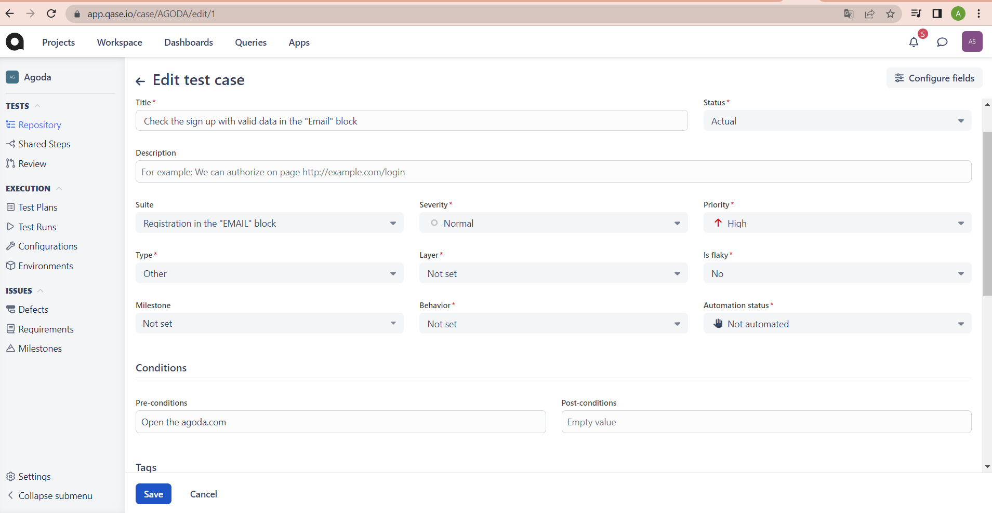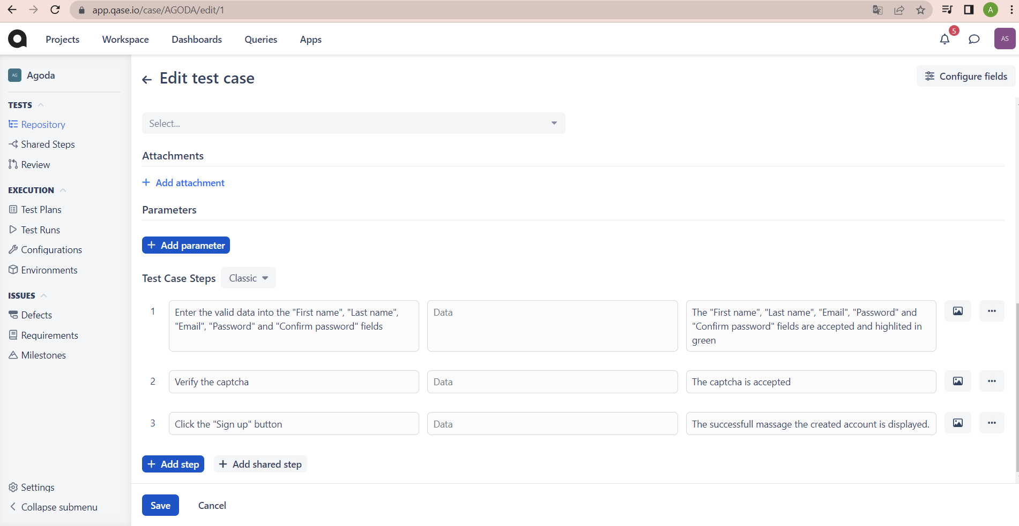

**Checklist example**

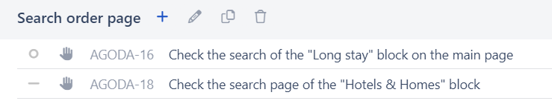

**5. Tools:**

1. Mind Map
2. QASE
3. Postman
4. SQLite
5. Android Studio
6. XCode
7. Charlees
8. ChromeDevtools
9. Certificates and Licenzes

**6. Resources**

QA1 - Hotels and Fligts

QA2 - Taxi Coupons

QA3 - Registration and Login

**7. Onboarding Plan**

**8. Test Execution:**

We start execution when User story moved to In Testing column

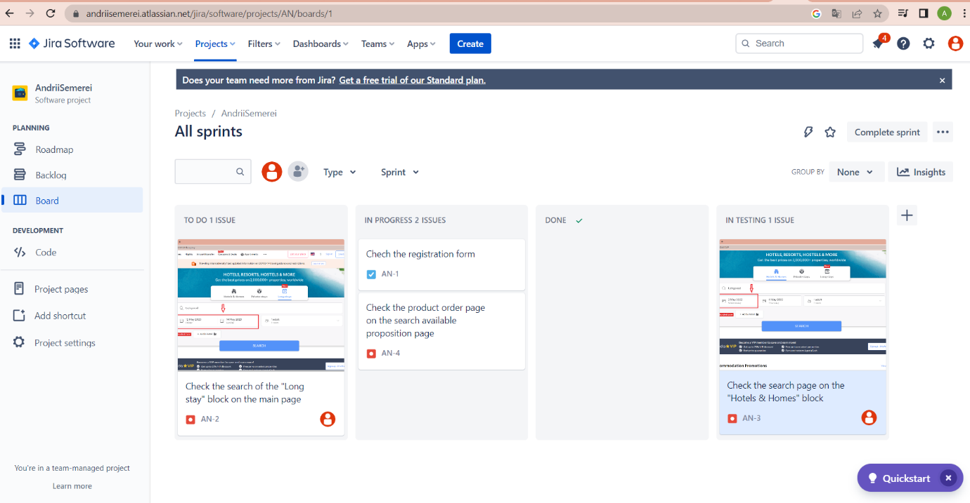

Create Test Run in QASE <https://app.qase.io/public/report/74e2ebc80259f639ad81ab9888250e25749a99ce>

Link Test cases with User Stories

<https://andriisemerei.atlassian.net/browse/AN-6>

**9. Bug Reporting:**

Create Bugs according to the instruction

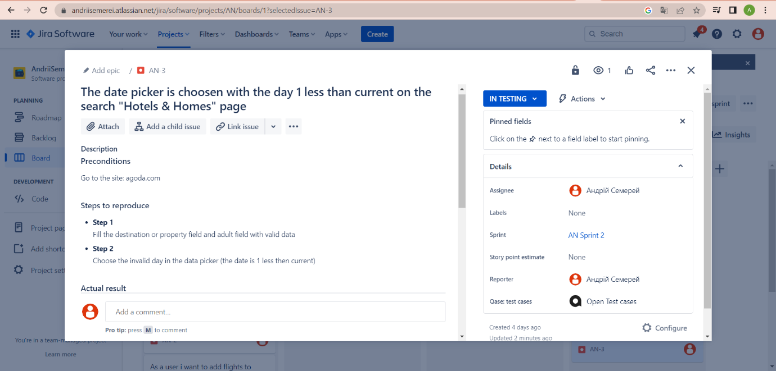

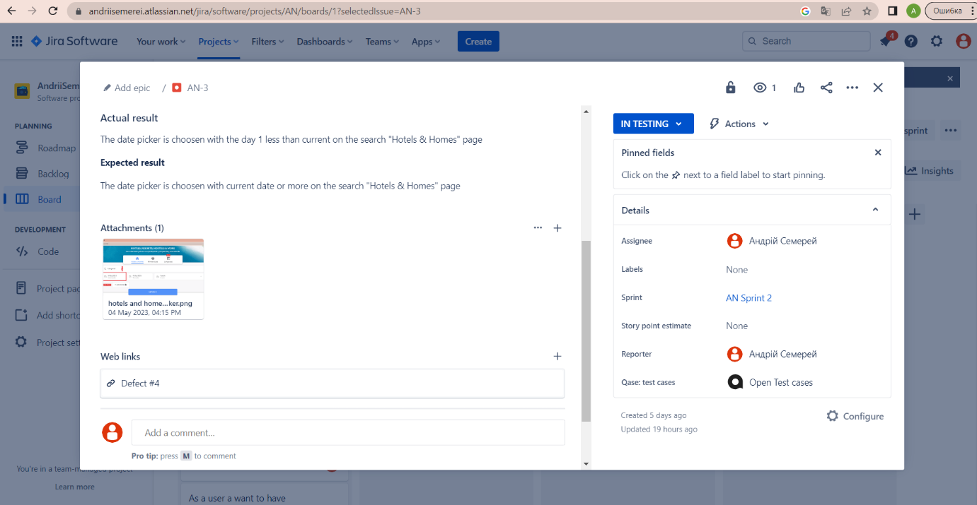

Bug triage

**Stages of Testing**

1. Testing of all User stories and tasks during Sprint
2. Smoke Testing
3. Regression Testing

**10. Test Environments:**

QA

Staging

Preprod

Prod

**11. Platforms and environments:**

***OS systems***

Windows

MacOS

***Mobile***

iOS

Android

***Devices***

Models

Resolution

OS

***Browsers***

Chrome

Safari

Opera

**Testing Strategy**

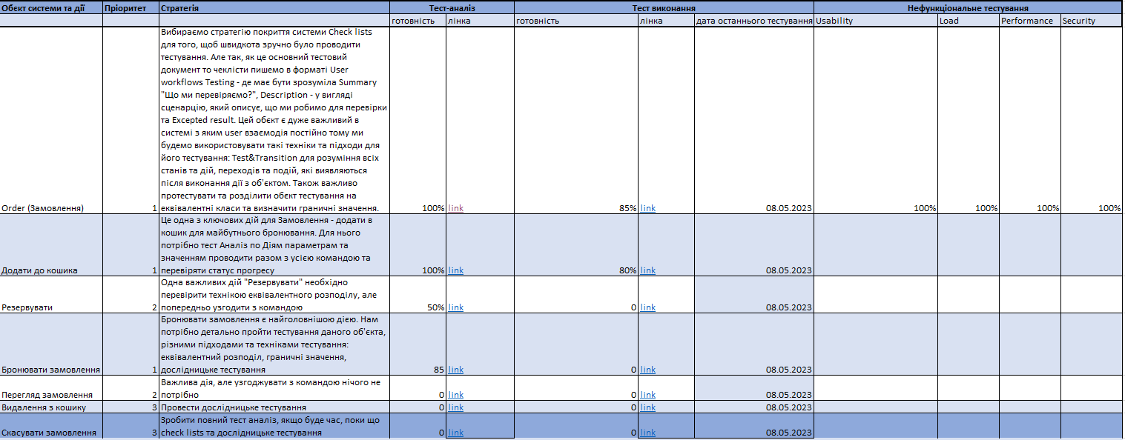

**12. Test Reporting**

**Links Test Runs** <https://app.qase.io/public/report/74e2ebc80259f639ad81ab9888250e25749a99ce>

**List of Bugs**

<https://andriisemerei.atlassian.net/browse/AN-3>

**Link on confluence page with Test Report**